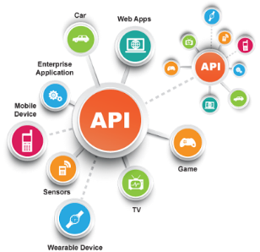**SE495 Software and Systems Integration**

**Integrating a Messaging System with a Web Application**

**Objective**

In this guided project, students will integrate a messaging system into a simple web application using an integration pattern and framework. The goal is to familiarize students with the concepts of integration patterns and frameworks, and to provide hands-on experience in applying these concepts.

**Duration**

This project should take approximately 3 hours to complete.

**Prerequisites**

* Basic understanding of web application development (HTML, CSS, JavaScript)
* Familiarity with Node.js and Express.js
* Knowledge of integration patterns and frameworks

**Instructions**

1. **Set up the project environment.** Create a new Node.js project and install the necessary dependencies, such as Express.js, for creating a simple web application.
2. **Create a simple web application.** Develop a basic web application with a form that allows users to submit a message. The message should include the user's name and the content of the message. Display the submitted messages on the web page in a list format.
3. **Choose an integration pattern.** Based on the concepts discussed in the chapter, select an appropriate integration pattern to integrate the messaging system into the web application. For example, you might choose the Publish-Subscribe pattern, which allows for asynchronous communication between the web application and the messaging system.
4. **Select an integration framework.** Choose an integration framework that supports the selected integration pattern and is compatible with Node.js. For example, you could use Apache Kafka, RabbitMQ, or NATS. Install the necessary packages for the chosen integration framework.
5. **Integrate the messaging system.** Modify the web application to use the chosen integration pattern and framework when submitting messages. The messages should be sent to the messaging system, and the web application should subscribe to receive messages from the messaging system. Display the received messages on the web page in real-time.
6. **Test the integration.** Verify that the web application and the messaging system are working correctly together. Submit messages through the web application and ensure that they are sent to the messaging system, and then displayed on the web page as expected.
7. **Document your work.** Write a brief report on the project, including the chosen integration pattern and framework, the steps taken to integrate the messaging system, and the results of the testing.

**Deliverables**

* A simple web application with integrated messaging system
* A brief report on the project and its outcomes

**Evaluation**

Students' work will be evaluated based on the following criteria:

* Successful integration of the messaging system with the web application
* Correct implementation of the chosen integration pattern
* Proper use of the selected integration framework
* Quality and clarity of the project documentation